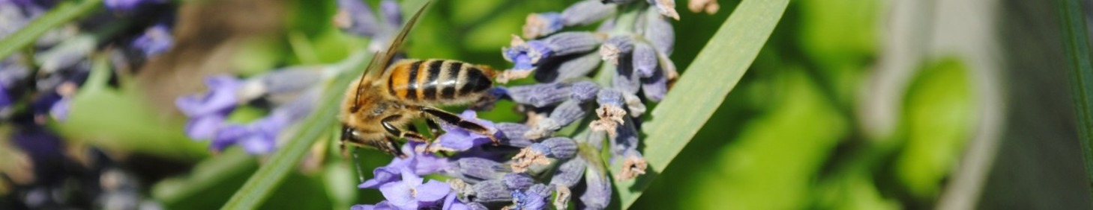

2026 TASTER COURSE APPLICATION FORM

Please enrol me on the Gravesend Beekeeping Taster Course being run on Sunday April 26th 10.00am -5.00pm at Gravesend’s Branch Apiary, Jeskyns Community Woodland, back entrance The Street Cobham DA12 3AL

Name……………………………………………………….

Address……………………………………………………..

………………………………………………………………

Tel. no………………………………………………………

Mobile……………………………………………………….

E-mail………………………………………………………..

Bank Transfer A/c name Kent Beekeepers
Sort code 60-09-10 account No. 16722825 - Identify as Taster Course
A £10 deposit (non-refundable) will secure your place.
A receipt will be issued. Course cost £60

Signature of applicant………………………………………….

The course will include all necessary handouts, beekeeping book, refreshments. Please bring a packed lunch.

Please return this application form to: By end of March as numbers are limited.

Mrs.L.Fancote,
Wayside,
Gorsewood Road,
Hartley, Longfield,
Kent DA3 7DE

Tel. no: 01474 702666

E-mail: lesleyfancote@msn.com

